SECTION 1: IDENTIFICATION OF THE SUBSTANCE/MIXTURE AND OF THE COMPANY/UNDERTAKING.

1.1 Product identifier.

Product Name: Phthalic anhydride
Product Code: Phthalic anhydride

1.2 Relevant identified uses of the substance or mixture and uses advised against.

Not available.

1.3 Details of the supplier of the safety data sheet.

Company: Varteco Quimica Puntana S.A

Address: Calle 113 entre 3 y 5 Parque Industrial Norte (5700)

City: San Luis

Province: San Luis

Telephone: +54 2664 425379

Fax: +54 2664 425379

E-mail: egarcia@varteco.com.ar

Web: www.varteco.com.ar

1.4 Emergency telephone number: +54 2664 425379 (Available 24 hours)

SECTION 2: HAZARDS IDENTIFICATION.

2.1 Classification of the substance or mixture.
In accordance with Regulation (EC) No 1272/2008:
Acute Tox. 4 : Harmful if swallowed.
Eye Dam. 1 : Causes serious eye damage.
Resp. Sens. 1 : May cause allergy or asthma symptoms or breathing difficulties if inhaled.
STOT SE 3 : May cause respiratory irritation.
Skin Irrit. 2 : Causes skin irritation.
Skin Sens. 1 : May cause an allergic skin reaction.

2.2 Label elements.
.
.
Labelling in accordance with Regulation (EC) No 1272/2008:
Pictograms:
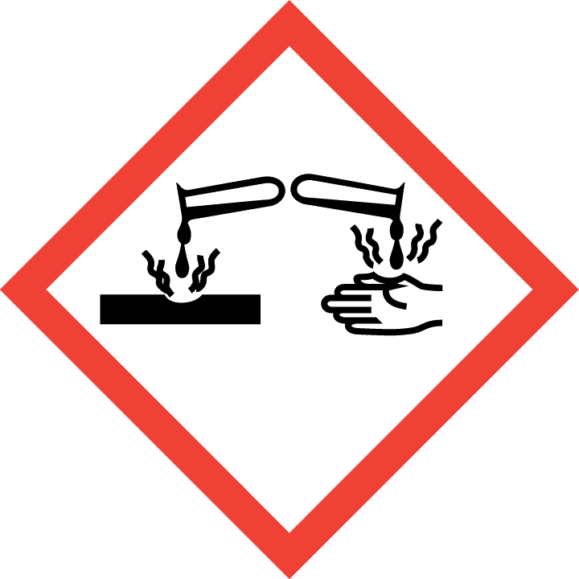 |  | 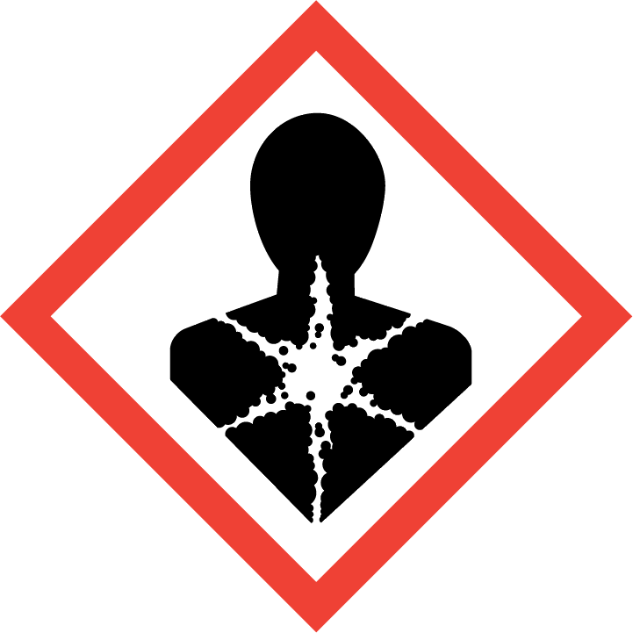
Signal Word:

Danger
Hazard statements:
H302 Harmful if swallowed.
H315 Causes skin irritation.
H317 May cause an allergic skin reaction.
H318 Causes serious eye damage.
H334 May cause allergy or asthma symptoms or breathing difficulties if inhaled.
H335 May cause respiratory irritation.
Precautionary statements:
P261 Avoid breathing dust/fume/gas/mist/vapours/spray.
P280 Wear protective gloves/protective clothing/eye protection/face protection/hearing protection/…
P284 [In case of inadequate ventilation] wear respiratory protection.
P305+P351+P338 IF IN EYES: Rinse cautiously with water for several minutes. Remove contact lenses, if present and easy to do. Continue rinsing.
P310 Immediately call a POISON CENTER/doctor/...
P321 Specific treatment (see ... on this label).
P342+P311 If experiencing respiratory symptoms: Call a POISON CENTER/doctor/...
Contains:
phthalic anhydride
maleic anhydride
2.3 Other hazards.
The mixture does not contain substances classified as PBT.
The mixture does not contain substances classified as vPvB.
The mixture does not contain any endocrine disrupting properties substances.
In normal use conditions and in its original form, the product itself does not involve any other risk for health and the environment.

SECTION 3: COMPOSITION/INFORMATION ON INGREDIENTS.

3.1 Substances.
Not applicable.

3.2 Mixtures.
Substances posing a danger to health or the environment in accordance with the Regulation (EC) No. 1272/2008, assigned a Community exposure limit in the workplace, and classified as PBT/vPvB or included in the Candidate List:

Identifiers | Name | Concentrate | (*)Classification - Regulation (EC) No 1272/2008
Identifiers | Name | Concentrate | Classification | Specifics concentration limits and Acute toxicity estimate
Index No: 607-009-00-4  CAS No: 85-44-9  EC No: 201-607-5  Registration No: 01-2119457017-41-XXXX | phthalic anhydride | 25 - 100 % | Acute Tox. 4 *, H302 - Eye Dam. 1, H318 - Resp. Sens. 1, H334 - STOT SE 3, H335 - Skin Irrit. 2, H315 - Skin Sens. 1, H317 | -
Index No: 607-096-00-9  CAS No: 108-31-6  EC No: 203-571-6  Registration No: 01-2119472428-31-XXXX | maleic anhydride | 0.001 - 1 % | Acute Tox. 4, H302 - Eye Dam. 1, H318 - Resp. Sens. 1, H334 - STOT RE 1, H372 - Skin Corr. 1B, H314 - Skin Sens. 1A, H317 | Skin Sens. 1A, H317: C ≥ 0,001 %
(*)The complete text of the H phrases is given in section 16 of this Safety Data Sheet.
* See Regulation (EC) No. 1272/2008, Annex VI, section 1.2.
[2] Substance with a national workplace exposure limit (see section 8.1).

SECTION 4: FIRST AID MEASURES.

IRRITANT MIXTURE. Its repeated or prolonged contact with the skin or mucous membranes can cause irritant symptoms such as reddening of the skin, blisters, or dermatitis. Some of the symptoms may not be immediate. They can cause allergic reactions on the skin.

4.1 Description of first aid measures.
In case of doubt or when symptoms of feeling unwell persist, get medical attention. Never administer anything orally to persons who are unconscious.

Inhalation.
Take the victim into open air; keep them warm and calm. If breathing is irregular or stops, perform artificial respiration. Do not administer anything orally. If unconscious, place them in a suitable position and seek medical assistance.

Eye contact.
Wash eyes with plenty of clean and cool water for at least 10 minutes while pulling eyelids up, and seek medical assistance. Dont let the person to rub the affected eye.

Skin contact.
Remove contaminated clothing. Wash skin vigorously with water and soap or a suitable skin cleaner. NEVER use solvents or thinners.

Ingestion.
If accidentally ingested, seek immediate medical attention. Keep calm. NEVER induce vomiting.

4.2 Most important symptoms and effects, both acute and delayed.
Corrosive Product, contact with eyes or skin can cause burns; ingestion or inhalation can cause internal damage, if this occurs immediate medical assistance is required.
Harmful Product, prolonged exposure due to inhalation may cause anaesthetic effects and the need for immediate medical assistance.
Contact with eyes may cause irreversible damage.
It may cause an allergic reaction, dermatitis, redness or inflammation of the skin.
It may cause an allergic reaction in the respiratory system. Chronic exposure can lead to asthma.

4.3 Indication of any immediate medical attention and special treatment needed.
In case of doubt or when symptoms of feeling unwell persist, get medical attention. Never administer anything orally to persons who are unconscious. Do not induce vomiting. If the person vomits, clear the respiratory tract.

SECTION 5: FIREFIGHTING MEASURES.

The product is NOT classified as flammable, in case of fire the following measures should be taken:

5.1 Extinguishing media.
Suitable extinguishing media:
Extinguisher powder or CO2. In case of more serious fires, also alcohol-resistant foam and water spray.

Unsuitable extinguishing media:
Do not use a direct stream of water to extinguish. In the presence of electrical voltage, you cannot use water or foam as extinguishing media.

5.2 Special hazards arising from the substance or mixture.
Special risks.
Exposure to combustion or decomposition products can be harmful to your health.

5.3 Advice for firefighters.
Use water to cool tanks, cisterns, or containers close to the heat source or fire. Take wind direction into account. Prevent the products used to fight the fire from going into drains, sewers, or waterways.

Fire protection equipment.
According to the size of the fire, it may be necessary to use protective suits against the heat, individual breathing equipment, gloves, protective goggles or facemasks, and boots.

SECTION 6: ACCIDENTAL RELEASE MEASURES.

6.1 Personal precautions, protective equipment and emergency procedures.

For exposure control and individual protection measures, see section 8.

6.2 Environmental precautions.
Product not classified as hazardous for the environment, avoid spillage as much as possible.

6.3 Methods and material for containment and cleaning up.
Contain and collect spillage with inert absorbent material (earth, sand, vermiculite, Kieselguhr...) and clean the area immediately with a suitable decontaminant.
Deposit waste in closed and suitable containers for disposal, in compliance with local and national regulations (see section 13).

6.4 Reference to other sections.
For exposure control and individual protection measures, see section 8.
For later elimination of waste, follow the recommendations under section 13.

SECTION 7: HANDLING AND STORAGE.

7.1 Precautions for safe handling.
For personal protection, see section 8.
In the application area, smoking, eating, and drinking must be prohibited.
Follow legislation on occupational health and safety.
Never use pressure to empty the containers. They are not pressure-resistant containers. Keep the product in containers made of a material identical to the original.

7.2 Conditions for safe storage, including any incompatibilities.
Store according to local legislation. Observe indications on the label. Store the containers between 5 and 25 º C, in a dry and well-ventilated place, far from sources of heat and direct solar light. Keep far away from ignition points. Keep away from oxidising agents and from highly acidic or alkaline materials. Do not smoke. Prevent the entry of non-authorised persons. Once the containers are open, they must be carefully closed and placed vertically to prevent spills.

The product is not affected by Directive 2012/18/EU (SEVESO III).

7.3 Specific end use(s).

Not available.

SECTION 8: EXPOSURE CONTROLS/PERSONAL PROTECTION.

8.1 Control parameters.

The product does NOT contain substances with Professional Exposure Environmental Limit Values.The product does NOT contain substances with Biological Limit Values.
Concentration levels DNEL/DMEL:

Name | DNEL/DMEL | Type | Value
phthalic anhydride  CAS No: 85-44-9  EC No: 201-607-5 | DNEL (Workers) | Inhalation, Chronic, Systemic effects | 32,2 (mg/m³)
maleic anhydride  CAS No: 108-31-6  EC No: 203-571-6 | DNEL (Workers) | Inhalation, Chronic, Local effects | 0,4 (mg/m³)
maleic anhydride  CAS No: 108-31-6  EC No: 203-571-6 | DNEL (Workers) | Inhalation, Chronic, Systemic effects | 0,4 (mg/m³)

DNEL: Derived No Effect Level, level of exposure to the substance below which adverse effects are not anticipated.
DMEL: Derived Minimal Effect Level, exposure level corresponding to a low risk, that risk should be considered a tolerable minimum.

8.2 Exposure controls.

Measures of a technical nature:

Provide adequate ventilation, which can be achieved by using good local exhaust-ventilation and a good general exhaust system.

Concentration: |  | 100 %
Uses:
Breathing protection:
PPE: |  | Particle filter mask |  |  |  | 
Characteristics: |  | «CE» marking, category III. Made of filtering material, it covers nose, mouth and chin.
CEN standards: |  | EN 149
Maintenance: |  | Check for any tears, defects, etc. before use. Since it is disposable individual protection equipment, it should be replaced after use.
Observations: |  | Does not protect worker unless properly adjusted. Follow the manufacturer's instructions regarding suitable use of the equipment.
Filter Type needed: |  | P2
Hand protection:
PPE: |  | Protective gloves against chemicals. |  |  |  | 
Characteristics: |  | «CE» marking, category III.
CEN standards: |  | EN 374-1, En 374-2, EN 374-3, EN 420
Maintenance: |  | Keep in a dry place, away from any sources of heat, and avoid exposure to sunlight as much as possible. Do not make any changes to the gloves that may alter their resistance, or apply paints, solvents or adhesives.
Observations: |  | Gloves should be of the appropriate size and fit the user's hand well, not being too loose or too tight. Always use with clean, dry hands.
Material: | PVC (polyvinyl chloride) |  | Breakthrough time (min.): | > 480 | Material thickness (mm): |  | 0,35
Eye protection:
PPE: |  | Protective goggles against particle impacts. |  |  |  | 
Characteristics: |  | «CE» marking, category II. Eye protector against dust and smoke.
CEN standards: |  | EN 165, EN 166, EN 167, EN 168
Maintenance: |  | Visibility through lenses should be ideal. Therefore, these parts should be cleaned daily. Protectors should be disinfected periodically following the manufacturer's instructions.
Observations: |  | Some signs of wear and tear include: yellow colouring of the lenses, superficial scratching of the lenses, scraping etc.
Skin protection:
PPE: |  | Protective clothing.
Characteristics: |  | «CE» marking, category II. Protective clothing should not be too tight or loose in order not to obstruct the user's movements.
CEN standards: |  | EN 340
Maintenance: |  | In order to guarantee uniform protection, follow the washing and maintenance instructions provided by the manufacturer.
Observations: |  | The protective clothing should offer a level of comfort in line with the level of protection provided in terms of the hazard against which it protects, bearing in mind environmental conditions, the user's level of activity and the expected time of use.
PPE: |  | Work footwear.
Characteristics: |  | «CE» marking, category II.
CEN standards: |  | EN ISO 13287, EN 20347
Maintenance: |  | This product adapts to the first user's foot shape. That is why, as well as for hygienic reasons, it should not be used by other people.
Observations: |  | Work footwear for professional use includes protection elements aimed at protecting users against any injury resulting from an accident

SECTION 9: PHYSICAL AND CHEMICAL PROPERTIES.

9.1 Information on basic physical and chemical properties.
Physical state: Solid - Dust
Colour: Not applicable/Not available due to the nature/properties of the product
Odour: Not applicable/Not available due to the nature/properties of the product
Odour threshold: Not applicable/Not available due to the nature/properties of the product
Melting point: Not applicable/Not available due to the nature/properties of the product
Freezing point: Not applicable/Not available due to the nature/properties of the product
Boiling point or initial boiling point and boiling range: Not applicable/Not available due to the nature/properties of the product
Flammability: Not applicable/Not available due to the nature/properties of the product
Lower explosion limit: Not applicable/Not available due to the nature/properties of the product
Upper explosion limit: Not applicable/Not available due to the nature/properties of the product
Flash point: > 60 ºC
Auto-ignition temperature: Not applicable/Not available due to the nature/properties of the product
Decomposition temperature: Not applicable/Not available due to the nature/properties of the product
pH: Not applicable/Not available due to the nature/properties of the product
Kinematic viscosity: Not applicable/Not available due to the nature/properties of the product
Solubility: Not applicable/Not available due to the nature/properties of the product
Hydrosolubility: Not applicable/Not available due to the nature/properties of the product
Liposolubility: Not applicable/Not available due to the nature/properties of the product
Partition coefficient n-octanol/water (log value): Not applicable/Not available due to the nature/properties of the product
Vapour pressure: Not applicable/Not available due to the nature/properties of the product
Absolute density: Not applicable/Not available due to the nature/properties of the product
Relative density: Not applicable/Not available due to the nature/properties of the product
Relative vapour density: Not applicable/Not available due to the nature/properties of the product
Particle characteristics: Not applicable/Not available due to the nature/properties of the product

9.2 Other information
Not applicable/Not available due to the nature/properties of the product

SECTION 10: STABILITY AND REACTIVITY.

10.1 Reactivity.
The product does not present hazards by their reactivity.

10.2 Chemical stability.
Stable under the recommended handling and storage conditions (see section 7).

10.3 Possibility of hazardous reactions.
The product does not present possibility of hazardous reactions.

10.4 Conditions to avoid.
Avoid any improper handling.

10.5 Incompatible materials.
Keep away from oxidising agents and from highly alkaline or acidic materials in order to prevent exothermic reactions.

10.6 Hazardous decomposition products.
No decomposition if used for the intended uses.

SECTION 11: TOXICOLOGICAL INFORMATION.
IRRITANT MIXTURE. The inhalation of spray mist or suspended particulates can irritate the respiratory tract. It can also cause serious respiratory difficulties, central nervous system disorders, and in extreme cases, unconsciousness.
IRRITANT MIXTURE. Its repeated or prolonged contact with the skin or mucous membranes can cause irritant symptoms such as reddening of the skin, blisters, or dermatitis. Some of the symptoms may not be immediate. They can cause allergic reactions on the skin.
11.1 Information on hazard classes as defined in Regulation (EC) Nº 1272/2008.
There are no tested data available on the product.
Repeated or prolonged contact with the product can cause the elimination of oil from the skin, giving rise to non-allergic contact dermatitis and absorption of the product through the skin.
Splatters in the eyes can cause irritation and reversible damage.

a) acute toxicity;
Product classified:
Acute toxicity (Oral), Category 4: Harmful if swallowed.
Acute Toxicity Estimate (ATE):
Mixtures:
ATE (Oral) = 500 mg/kg
b) skin corrosion/irritation;
Product classified:
Skin irritant, Category 2: Causes skin irritation.
c) serious eye damage/irritation;
Product classified:
Serious eye damage, Category 1: Causes serious eye damage.
d) respiratory or skin sensitisation;
Product classified:
Respiratory sensitiser, Category 1: May cause allergy or asthma symptoms or breathing difficulties if inhaled.
Skin sensitiser, Category 1: May cause an allergic skin reaction.
e) germ cell mutagenicity;
Not conclusive data for classification.
f) carcinogenicity;
Not conclusive data for classification.
g) reproductive toxicity;
Not conclusive data for classification.
h) STOT-single exposure;
Product classified:
Specific target organ toxicity following a single exposure, Category 3: May cause respiratory irritation.
i) STOT-repeated exposure;
Based on available data, the classification criteria are not met.
j) aspiration hazard;
Not conclusive data for classification.

11.2 Information on other hazards.
Endocrine disrupting properties
This product does not contain components with endocrine-disrupting properties with effects on human health.
Other information
There is no information available on other adverse health effects.

SECTION 12: ECOLOGICAL INFORMATION.

12.1 Toxicity.
No information is available regarding the ecotoxicity of the substances present.

12.2 Persistence and degradability.
No information is available regarding the biodegradability of the substances present.
No information is available on the degradability of the substances present.
No information is available about persistence and degradability of the product.

12.3 Bioaccumulative potential.
Information about the bioaccumulation of the substances present.

Name |  | Bioaccumulation
 |  | Log Pow | BCF | NOECs | Level
phthalic anhydride |  | 1,6 | - | - | Very low
CAS No: 85-44-9 | EC No: 201-607-5

12.4 Mobility in soil.
No information is available about the mobility in soil.
The product must not be allowed to go into sewers or waterways.
Prevent penetration into the ground.

12.5 Results of PBT and vPvB assessment.
No information is available about the results of PBT and vPvB assessment of the product.

12.6 Endocrine disrupting properties.
This product doesn't contain components with environmental endocrine disrupting properties.

12.7 Other adverse effects.
The product is not affected by the Regulation (EC) No 1005/2009 of the European Parliament and of the Council of 16 September 2009 on substances that deplete the ozone layer.
No information is available about other adverse effects for the environment.

SECTION 13: DISPOSAL CONSIDERATIONS.

13.1 Waste treatment methods.
Do not dump into sewers or waterways. Waste and empty containers must be handled and eliminated according to current, local/national legislation.
Follow the provisions of Directive 2008/98/EC regarding waste management.

SECTION 14: TRANSPORT INFORMATION.

Transportation is not dangerous. In case of road accident causing the product’s spillage, proceed in accordance with point 6.

14.1 UN number or ID number.
Transportation is not dangerous.

14.2 UN proper shipping name.
Description:
ADR/RID: Not classified as hazardous for transport.
IMDG: Not classified as hazardous for transport.
ICAO/IATA: Not classified as hazardous for transport.

14.3 Transport hazard class(es).
Transportation is not dangerous.

14.4 Packing group.
Transportation is not dangerous.

14.5 Environmental hazards.
Transportation is not dangerous.
Transport by ship, FEm – Emergency sheets (F – Fire, S - Spills): Not applicable.

14.6 Special precautions for user.
Transportation is not dangerous.

14.7 Maritime transport in bulk according to IMO instruments.
Not classified as hazardous for transport.

SECTION 15: REGULATORY INFORMATION.

15.1 Safety, health and environmental regulations/legislation specific for the substance or mixture.

The product is not affected by Regulation (EU) No 528/2012 concerning the making available on the market and use of biocidal products.
The product is not affected by the procedure established Regulation (EU) No 649/2012, concerning the export and import of dangerous chemicals.
Restrictions on the manufacturing, placing on the market and use of certain dangerous substances, mixtures and articles:

Designation of the substance, of the group of substances or of the mixture | Conditions of restriction
3. Liquid substances or mixtures fulfilling the criteria for any of the following hazard classes or categories set out in Annex I to Regulation (EC) No 1272/2008:  (a) hazard classes 2.1 to 2.4, 2.6 and 2.7, 2.8 types A and B, 2.9, 2.10, 2.12, 2.13 categories 1 and 2, 2.14 categories 1 and 2, 2.15 types A to F;  (b) hazard classes 3.1 to 3.6, 3.7 adverse effects on sexual function and fertility or on development, 3.8 effects other than narcotic effects, 3.9 and 3.10;  (c) hazard class 4.1;  (d) hazard class 5.1. | 1. Shall not be used in:  - ornamental articles intended to produce light or colour effects by means of different phases, for example in ornamental lamps and ashtrays,  - tricks and jokes,  - games for one or more participants, or any article intended to be used as such, even with ornamental aspects,  2. Articles not complying with paragraph 1 shall not be placed on the market.  3. Shall not be placed on the market if they contain a colouring agent, unless required for fiscal reasons, or perfume, or both, if they:  - can be used as fuel in decorative oil lamps for supply to the general public, and,  - present an aspiration hazard and are labelled with H304,  4. Decorative oil lamps for supply to the general public shall not be placed on the market unless they conform to the European Standard on Decorative oil lamps (EN 14059) adopted by the European Committee for Standardisation (CEN).  5. Without prejudice to the implementation of other Community provisions relating to the classification, packaging and labelling of dangerous substances and mixtures, suppliers shall ensure, before the placing on the market, that the following requirements are met:  (a) lamp oils, labelled with H304, intended for supply to the general public are visibly, legibly and indelibly marked as follows: ‘Keep lamps filled with this liquid out of the reach of children’; and, by 1 December 2010, ‘Just a sip of lamp oil - or even sucking the wick of lamps - may lead to life-threatening lung damage’;  (b) grill lighter fluids, labelled with H304, intended for supply to the general public are legibly and indelibly marked by 1 December 2010 as follows: ‘Just a sip of grill lighter may lead to life threatening lung damage’;  (c) lamp oils and grill lighters, labelled with H304, intended for supply to the general public are packaged in black opaque containers not exceeding 1 litre by 1 December 2010.  .

15.2 Chemical safety assessment.
No Chemical Safety Assessment has been carried out for this substance/mixture by the supplier.

SECTION 16: OTHER INFORMATION.

Complete text of the H phrases that appear in section 3:

H302 Harmful if swallowed.
H314 Causes severe skin burns and eye damage.
H315 Causes skin irritation.
H317 May cause an allergic skin reaction.
H318 Causes serious eye damage.
H334 May cause allergy or asthma symptoms or breathing difficulties if inhaled.
H335 May cause respiratory irritation.
H372 Causes damage to organs through prolonged or repeated exposure.

Classification codes:

Acute Tox. 4 : Acute toxicity (Oral), Category 4
Eye Dam. 1 : Serious eye damage, Category 1
Resp. Sens. 1 : Respiratory sensitiser, Category 1
STOT RE 1 : Specific target organ toxicity following a repeated exposure, Category 1
STOT SE 3 : Specific target organ toxicity following a single exposure, Category 3
Skin Corr. 1B : Skin Corrosive, Category 1B
Skin Irrit. 2 : Skin irritant, Category 2
Skin Sens. 1 : Skin sensitiser, Category 1
Skin Sens. 1A : Skin sensitiser, Category 1A

Classification and procedure used to derive the classification for mixtures according to Regulation (EC) 1272/2008 [CLP]:
Physical hazards On basis of test data
Health hazards Calculation method
Environmental hazards Calculation method

It is advisable to carry out basic training with regard to health and safety at work in order to handle this product correctly.

Risk classification system NFPA 704:
  0  3  0 | Health hazard: 3 (Extreme Danger)  Flammability: 0 (Will not burn)  Reactivity: 0 (Stable)
Abbreviations and acronyms used:
BCF: Bioconcentration factor.
CEN: European Committee for Standardization.
DMEL: Derived Minimal Effect Level, exposure level corresponding to a low risk, that risk should be
considered a tolerable minimum.
DNEL: Derived No Effect Level, level of exposure to the substance below which adverse effects are not
anticipated.
EC50: Half maximal effective concentration.
PPE: Personal protection equipment.
LC50: Lethal concentration, 50%.
LD50: Lethal dose, 50%.
NOEC: No observed effect concentration.
Key literature references and sources for data:
http://eur-lex.europa.eu/homepage.html
http://echa.europa.eu/
Regulation (EU) 2020/878.
Regulation (EC) No 1907/2006.
Regulation (EC) No 1272/2008.

The information given in this Safety Data Sheet has been drafted in accordance with COMMISSION REGULATION (EU) 2020/878 of 18 June 2020 amending Annex II to Regulation (EC) No 1907/2006 of the European Parliament and of the Council on the Registration, Evaluation, Authorisation and Restriction of Chemical substances and mixtures (REACH).

The information in this Safety Data Sheet on the Preparation is based on current knowledge and on current EC and national laws, as far as the working conditions of the users is beyond our knowledge and control. The product must not be used for purposes other than those that are specified without first having written instructions on how to handle. It is always the responsibility of the user to take the appropriate measures in order to comply with the requirements established by current legislation. The information contained in this Safety Sheet only states a description of the safety requirements for the preparation, and it must not be considered as a guarantee of its properties.

