SECTION 1: IDENTIFICATION OF THE SUBSTANCE/MIXTURE AND OF THE COMPANY/UNDERTAKING.

1.1 Product identifier.

Product Name: Kalflex 18
Product Code: K18

1.2 Relevant identified uses of the substance or mixture and uses advised against.

Plastificante

Uses advised against:
Uses other than those recommended.

1.3 Details of the supplier of the safety data sheet.

Company: Varteco Quimica Puntana S.A

Address: Calle 113 entre 3 y 5 Parque Industrial Norte (5700)

City: San Luis

Province: San Luis

Telephone: +54 2664 425379

Fax: +54 2664 425379

E-mail: egarcia@varteco.com.ar

Web: www.varteco.com.ar

1.4 Emergency telephone number: +54 2664 425379 (Available 24 hours)

SECTION 2: HAZARDS IDENTIFICATION.

2.1 Classification of the substance or mixture.
In accordance with Regulation (EC) No 1272/2008:
Aquatic Acute 1 : Very toxic to aquatic life.
STOT RE 2 : May cause damage to organs through prolonged or repeated exposure.
Skin Sens. 1 : May cause an allergic skin reaction.

2.2 Label elements.
.
.
Labelling in accordance with Regulation (EC) No 1272/2008:
Pictograms:
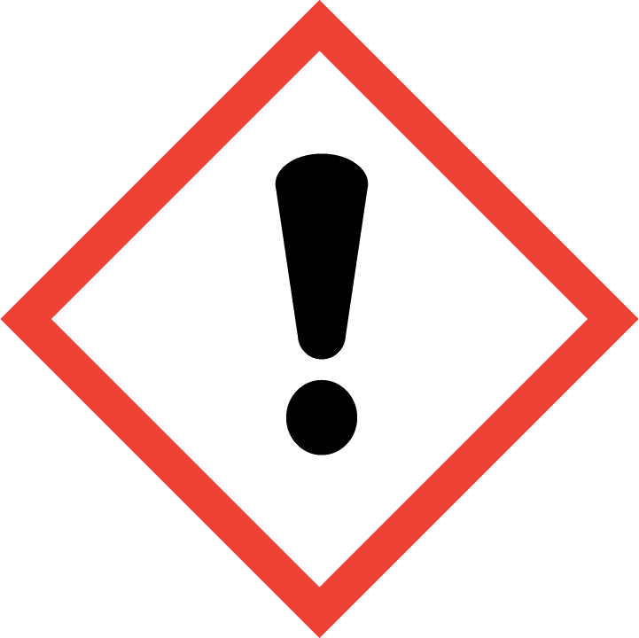 | 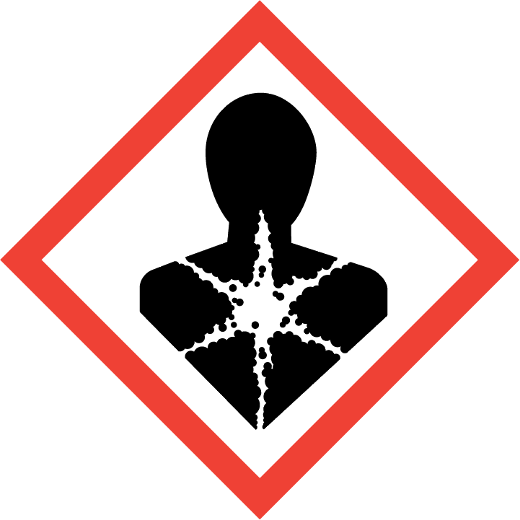 | 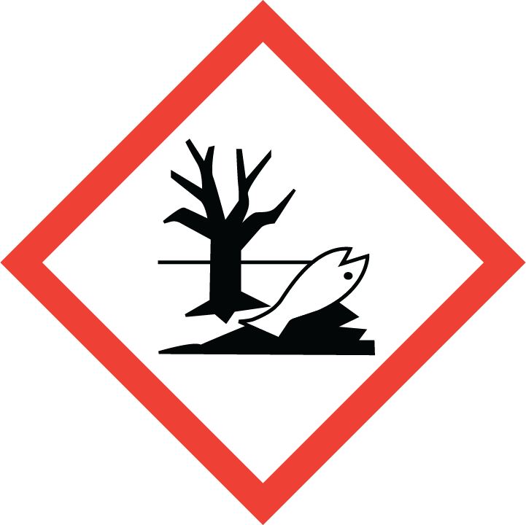
Signal Word:

Warning
Hazard statements:
H317 May cause an allergic skin reaction.
H373 May cause damage to organs through prolonged or repeated exposure.
H400 Very toxic to aquatic life.
Precautionary statements:
COPIA
CONTROLADA
P260 Do not breathe dust/fume/gas/mist/vapours/spray.
P273 Avoid release to the environment.
P280 Wear protective gloves/protective clothing/eye protection/face protection/hearing protection/…
P321 Specific treatment (see ... on this label).
P362+P364 Take off contaminated clothing and wash it before reuse.
P391 Collect spillage.
P501 Dispose of contents/container to …
COPIA
CONTROLADA
Contains:
Dibutyl maleate
2.3 Other hazards.
The mixture does not contain substances classified as PBT.
The mixture does not contain substances classified as vPvB.
The mixture does not contain any endocrine disrupting properties substances.
In normal use conditions and in its original form, the product itself does not involve any other risk for health and the environment.

SECTION 3: COMPOSITION/INFORMATION ON INGREDIENTS.

3.1 Substances.
Not Applicable.

3.2 Mixtures.
Substances posing a danger to health or the environment in accordance with the Regulation (EC) No. 1272/2008, assigned a Community exposure limit in the workplace, and classified as PBT/vPvB or included in the Candidate List:

Identifiers | Name | Concentrate | (*)Classification - Regulation (EC) No 1272/2008
Identifiers | Name | Concentrate | Classification | Specifics concentration limits and Acute toxicity estimate
CAS No: 105-76-0  EC No: 203-328-4  Registration No: 01-2119523581-45-XXXX | Dibutyl maleate | 25 - 100 % | Aquatic Acute 1, H400 - STOT RE 2, H373 - Skin Sens. 1, H317 | -
(*)The complete text of the H phrases is given in section 16 of this Safety Data Sheet.

SECTION 4: FIRST AID MEASURES.

4.1 Description of first aid measures.
In case of doubt or when symptoms of feeling unwell persist, get medical attention. Never administer anything orally to persons who are unconscious.

Inhalation.
Take the victim into open air; keep them warm and calm. If breathing is irregular or stops, perform artificial respiration.

Eye contact.
Remove contact lenses, if present and if it is easy to do. Wash eyes with plenty of clean and cool water for at least 10 minutes while pulling eyelids up, and seek medical assistance.

Skin contact.
Remove contaminated clothing. Wash skin vigorously with water and soap or a suitable skin cleaner. NEVER use solvents or thinners.

Ingestion.
If accidentally ingested, seek immediate medical attention. Keep calm. NEVER induce vomiting.

4.2 Most important symptoms and effects, both acute and delayed.
Long-term chronic exposure may result in injury to certain organs or tissues.
It may cause an allergic reaction, dermatitis, redness or inflammation of the skin.

4.3 Indication of any immediate medical attention and special treatment needed.
In case of doubt or when symptoms of feeling unwell persist, get medical attention. Never administer anything orally to persons who are unconscious. Keep the person comfortable. Turn him/her over to the left side and stay there while waiting for medical care.

SECTION 5: FIREFIGHTING MEASURES.

The product does not present any particular risk in case of fire.

5.1 Extinguishing media.
Suitable extinguishing media:
Extinguisher powder or CO2. In case of more serious fires, also alcohol-resistant foam and water spray.

Unsuitable extinguishing media:
Do not use a direct stream of water to extinguish. In the presence of electrical voltage, you cannot use water or foam as extinguishing media.

5.2 Special hazards arising from the substance or mixture.
Special risks.
Exposure to combustion or decomposition products can be harmful to your health.

5.3 Advice for firefighters.
Use water to cool tanks, cisterns, or containers close to the heat source or fire. Take wind direction into account. Prevent the products used to fight the fire from going into drains, sewers, or waterways. Product residues and extinguishing media may contaminate the aquatic environment.

Fire protection equipment.
According to the size of the fire, it may be necessary to use protective suits against the heat, individual breathing equipment, gloves, protective goggles or facemasks, and boots.

SECTION 6: ACCIDENTAL RELEASE MEASURES.

6.1 Personal precautions, protective equipment and emergency procedures.

For exposure control and individual protection measures, see section 8.

6.2 Environmental precautions.
Product dangerous for the environment, in case of large spills or if the product contaminates lakes, rivers, or sewers, inform the responsible authorities according to local legislation. Prevent the contamination of drains, surface or subterranean waters, and the ground.

6.3 Methods and material for containment and cleaning up.
Contain and collect spillage with inert absorbent material (earth, sand, vermiculite, Kieselguhr...) and clean the area immediately with a suitable decontaminant.
Deposit waste in closed and suitable containers for disposal, in compliance with local and national regulations (see section 13).

6.4 Reference to other sections.
For exposure control and individual protection measures, see section 8.
For later elimination of waste, follow the recommendations under section 13.

SECTION 7: HANDLING AND STORAGE.

7.1 Precautions for safe handling.
For personal protection, see section 8.
In the application area, smoking, eating, and drinking must be prohibited.
Follow legislation on occupational health and safety.
Never use pressure to empty the containers. They are not pressure-resistant containers. Keep the product in containers made of a material identical to the original.

7.2 Conditions for safe storage, including any incompatibilities.
Store according to local legislation. Observe indications on the label. Store the containers between 5 and 25 º C, in a dry and well-ventilated place, far from sources of heat and direct solar light. Keep far away from ignition points. Keep away from oxidising agents and from highly acidic or alkaline materials. Do not smoke. Prevent the entry of non-authorised persons. Once the containers are open, they must be carefully closed and placed vertically to prevent spills.

The product is not affected by Directive 2012/18/EU (SEVESO III).

7.3 Specific end use(s).

Not available.

SECTION 8: EXPOSURE CONTROLS/PERSONAL PROTECTION.

8.1 Control parameters.

The product does NOT contain substances with Professional Exposure Environmental Limit Values.The product does NOT contain substances with Biological Limit Values.

8.2 Exposure controls.

Measures of a technical nature:

Provide adequate ventilation, which can be achieved by using good local exhaust-ventilation and a good general exhaust system.

Concentration: |  | 100 %
Uses: |  | Plastificante
Breathing protection:
PPE: |  | Filter mask for protection against gases and particles. |  |  |  | 
Characteristics: |  | «CE» marking, category III. The mask must have a wide field of vision and an anatomically designed form in order to be sealed and watertight.
CEN standards: |  | EN 136, EN 140, EN 405
Maintenance: |  | Should not be stored in places exposed to high temperatures and damp environments before use. Special attention should be paid to the state of the inhalation and exhalation valves in the face adaptor.
Observations: |  | Read carefully the manufacturer's instructions regarding the equipment's use and maintenance. Attach the necessary filters to the equipment according to the specific nature of the risk (Particles and aerosols: P1-P2-P3, Gases and vapours: A-B-E-K-AX), changing them as advised by the manufacturer.
Filter Type needed: |  | A2
Hand protection:
PPE: |  | Protective gloves against chemicals. |  |  |  | 
Characteristics: |  | «CE» marking, category III.
CEN standards: |  | EN 374-1, En 374-2, EN 374-3, EN 420
Maintenance: |  | Keep in a dry place, away from any sources of heat, and avoid exposure to sunlight as much as possible. Do not make any changes to the gloves that may alter their resistance, or apply paints, solvents or adhesives.
Observations: |  | Gloves should be of the appropriate size and fit the user's hand well, not being too loose or too tight. Always use with clean, dry hands.
Material: | PVC (polyvinyl chloride) |  | Breakthrough time (min.): | > 480 | Material thickness (mm): |  | 0,35
Eye protection:
PPE: |  | Protective goggles with built-in frame. |  |  |  | 
Characteristics: |  | «CE» marking, category II. Eye protector with built-in frame for protection against dust, smoke, fog and vapour.
CEN standards: |  | EN 165, EN 166, EN 167, EN 168
Maintenance: |  | Visibility through lenses should be ideal. Therefore, these parts should be cleaned daily. Protectors should be disinfected periodically following the manufacturer's instructions.
Observations: |  | Some signs of wear and tear include: yellow colouring of the lenses, superficial scratching of the lenses, scraping etc.
Skin protection:
PPE: |  | Protective clothing.
Characteristics: |  | «CE» marking, category II. Protective clothing should not be too tight or loose in order not to obstruct the user's movements.
CEN standards: |  | EN 340
Maintenance: |  | In order to guarantee uniform protection, follow the washing and maintenance instructions provided by the manufacturer.
Observations: |  | The protective clothing should offer a level of comfort in line with the level of protection provided in terms of the hazard against which it protects, bearing in mind environmental conditions, the user's level of activity and the expected time of use.
PPE: |  | Work footwear.
Characteristics: |  | «CE» marking, category II.
CEN standards: |  | EN ISO 13287, EN 20347
Maintenance: |  | This product adapts to the first user's foot shape. That is why, as well as for hygienic reasons, it should not be used by other people.
Observations: |  | Work footwear for professional use includes protection elements aimed at protecting users against any injury resulting from an accident

SECTION 9: PHYSICAL AND CHEMICAL PROPERTIES.

9.1 Information on basic physical and chemical properties.
Physical state: Liquid
Colour: Not applicable/Not available due to the nature/properties of the product
Odour: Not applicable/Not available due to the nature/properties of the product
Odour threshold: Not applicable/Not available due to the nature/properties of the product
Melting point: Not applicable/Not available due to the nature/properties of the product
Freezing point: Not applicable/Not available due to the nature/properties of the product
Boiling point or initial boiling point and boiling range: >280 ºC
Flammability: Not applicable/Not available due to the nature/properties of the product
Lower explosion limit: Not applicable/Not available due to the nature/properties of the product
Upper explosion limit: Not applicable/Not available due to the nature/properties of the product
Flash point: >134 ºC
Auto-ignition temperature: Not applicable/Not available due to the nature/properties of the product
Decomposition temperature: Not applicable/Not available due to the nature/properties of the product
pH: Not applicable/Not available due to the nature/properties of the product
Kinematic viscosity: Not applicable/Not available due to the nature/properties of the product
Solubility: Not applicable/Not available due to the nature/properties of the product
Hydrosolubility: Not applicable/Not available due to the nature/properties of the product
Liposolubility: Not applicable/Not available due to the nature/properties of the product
Partition coefficient n-octanol/water (log value): Not applicable/Not available due to the nature/properties of the product
Vapour pressure: Not applicable/Not available due to the nature/properties of the product
Absolute density: Not applicable/Not available due to the nature/properties of the product
Relative density: Not applicable/Not available due to the nature/properties of the product
Relative vapour density: Not applicable/Not available due to the nature/properties of the product
Particle characteristics: Not applicable/Not available due to the nature/properties of the product

9.2 Other information
Not applicable/Not available due to the nature/properties of the product

SECTION 10: STABILITY AND REACTIVITY.

10.1 Reactivity.
The product does not present hazards by their reactivity.

10.2 Chemical stability.
Unstable in contact with:
- Acids.
- Bases.
- Oxidizing agents.

10.3 Possibility of hazardous reactions.
In certain conditions this may cause a polymerization reaction.

10.4 Conditions to avoid.
Avoid the following conditions:
- Heating.
- High temperature.
- Contact with incompatible materials.

10.5 Incompatible materials.
Avoid the following materials:
- Acids.
- Bases.
- Oxidizing agents.

10.6 Hazardous decomposition products.
Depending on conditions of use, can be generated the following products:
- COx (carbon oxides).
- Organic compounds.

SECTION 11: TOXICOLOGICAL INFORMATION.

11.1 Information on hazard classes as defined in Regulation (EC) Nº 1272/2008.
There are no tested data available on the product.

a) acute toxicity;
Not conclusive data for classification.
b) skin corrosion/irritation;
Not conclusive data for classification.
c) serious eye damage/irritation;
Not conclusive data for classification.
d) respiratory or skin sensitisation;
Product classified:
Skin sensitiser, Category 1: May cause an allergic skin reaction.
e) germ cell mutagenicity;
Not conclusive data for classification.
f) carcinogenicity;
Not conclusive data for classification.
g) reproductive toxicity;
Not conclusive data for classification.
h) STOT-single exposure;
Not conclusive data for classification.
i) STOT-repeated exposure;
Product classified:
Specific target organ toxicity following a repeated exposure, Category 2: May cause damage to organs through prolonged or repeated exposure.
j) aspiration hazard;
Not conclusive data for classification.

11.2 Information on other hazards.
Endocrine disrupting properties
This product does not contain components with endocrine-disrupting properties with effects on human health.
Other information
There is no information available on other adverse health effects.

SECTION 12: ECOLOGICAL INFORMATION.

12.1 Toxicity.
No information is available regarding the ecotoxicity of the substances present.

12.2 Persistence and degradability.
No information is available regarding the biodegradability of the substances present.
No information is available on the degradability of the substances present.
No information is available about persistence and degradability of the product.

12.3 Bioaccumulative potential.
No information is available regarding the bioaccumulation of the substances present.

12.4 Mobility in soil.
No information is available about the mobility in soil.
The product must not be allowed to go into sewers or waterways.
Prevent penetration into the ground.

12.5 Results of PBT and vPvB assessment.
No information is available about the results of PBT and vPvB assessment of the product.

12.6 Endocrine disrupting properties.
This product doesn't contain components with environmental endocrine disrupting properties.

12.7 Other adverse effects.
No information is available about other adverse effects for the environment.

SECTION 13: DISPOSAL CONSIDERATIONS.

13.1 Waste treatment methods.
Do not dump into sewers or waterways. Waste and empty containers must be handled and eliminated according to current, local/national legislation.
Follow the provisions of Directive 2008/98/EC regarding waste management.

SECTION 14: TRANSPORT INFORMATION.

Transportation is not dangerous. In case of road accident causing the product’s spillage, proceed in accordance with point 6.

14.1 UN number or ID number.
Transportation is not dangerous.

14.2 UN proper shipping name.
Description:
ADR/RID: Not classified as hazardous for transport.
IMDG: Not classified as hazardous for transport.
ICAO/IATA: Not classified as hazardous for transport.

14.3 Transport hazard class(es).
Transportation is not dangerous.

14.4 Packing group.
Transportation is not dangerous.

14.5 Environmental hazards.
Transportation is not dangerous.
Transport by ship, FEm – Emergency sheets (F – Fire, S - Spills): Not applicable.

14.6 Special precautions for user.
Transportation is not dangerous.

14.7 Maritime transport in bulk according to IMO instruments.
Transportation is not dangerous.

SECTION 15: REGULATORY INFORMATION.

15.1 Safety, health and environmental regulations/legislation specific for the substance or mixture.
The product is not affected by the Regulation (EC) No 1005/2009 of the European Parliament and of the Council of 16 September 2009 on substances that deplete the ozone layer.

Product classification according to Annex I of Directive 2012/18/EU (SEVESO III): N/A
The product is not affected by Regulation (EU) No 528/2012 concerning the making available on the market and use of biocidal products.
The product is not affected by the procedure established Regulation (EU) No 649/2012, concerning the export and import of dangerous chemicals.

15.2 Chemical safety assessment.
No Chemical Safety Assessment has been carried out for this substance/mixture by the supplier.

SECTION 16: OTHER INFORMATION.

Complete text of the H phrases that appear in section 3:

H317 May cause an allergic skin reaction.
H373 May cause damage to organs through prolonged or repeated exposure.
H400 Very toxic to aquatic life.

Classification codes:

Aquatic Acute 1 : Acute toxicity to the aquatic environment, Category 1
STOT RE 2 : Specific target organ toxicity following a repeated exposure, Category 2
Skin Sens. 1 : Skin sensitiser, Category 1

Changes regarding to the previous version:
- Changes in the information of the supplier (SECTION 1.3).
- Change in the emergency number (SECTION 1.4).
- Modification of specific hazards (SECTION 2.3).
- Modification in the firefighting measures (SECTION 5.2).
- Modifications in the accidental release measures (SECTION 6.1).
- Modifications in the accidental release measures (SECTION 6.2).
- Modification in the values of the physical and chemical properties (SECTION 9).
- Change in the hazard classification (SECTION 11.1).
- Modification of the classification ADR/IMDG/ICAO/IATA/RID (SECTION 14).

Classification and procedure used to derive the classification for mixtures according to Regulation (EC) 1272/2008 [CLP]:
Physical hazards On basis of test data
Health hazards Calculation method
Environmental hazards Calculation method

It is advisable to carry out basic training with regard to health and safety at work in order to handle this product correctly.

Risk classification system NFPA 704:
  2  0  0 | Health hazard: 2 (Hazardous)  Flammability: 0 (Will not burn)  Reactivity: 0 (Stable)
Abbreviations and acronyms used:
CEN: European Committee for Standardization.
PPE: Personal protection equipment.
Key literature references and sources for data:
http://eur-lex.europa.eu/homepage.html
http://echa.europa.eu/
Regulation (EU) 2020/878.
Regulation (EC) No 1907/2006.
Regulation (EC) No 1272/2008.

The information given in this Safety Data Sheet has been drafted in accordance with COMMISSION REGULATION (EU) 2020/878 of 18 June 2020 amending Annex II to Regulation (EC) No 1907/2006 of the European Parliament and of the Council on the Registration, Evaluation, Authorisation and Restriction of Chemical substances and mixtures (REACH).
The information in this Safety Data Sheet on the Preparation is based on current knowledge and on current EC and national laws, as far as the working conditions of the users is beyond our knowledge and control. The product must not be used for purposes other than those that are specified without first having written instructions on how to handle. It is always the responsibility of the user to take the appropriate measures in order to comply with the requirements established by current legislation. The information contained in this Safety Sheet only states a description of the safety requirements for the preparation, and it must not be considered as a guarantee of its properties.

